Discusión — versión 6
v6, 2026-09-14 — sobre la v5. Cambios en la Sección 2 y cierre de la Sección 3. Ningún número nuevo.
1) Título de la Sección 2 cambiado a “Baseline variation across the elevational gradient and the lack of response to nutrient addition”: “main driver” afirmaba causalidad que el diseño no sostiene (3 sitios, 2 especies cada uno, especie y elevación confundidas). Por la misma razón se suavizó “the altitudinal gradient was the main driver” y la frase de que el gradiente funciona como “a control for that prediction”, y se añadió una frase declarando explícitamente el confundido. 2) Nuevo párrafo de limitaciones de la iWUE isotópica, situado antes de los mecanismos: parámetros globales (a, b, f y Γ*(T) de Bernacchi et al. 2001) en vez de específicos por especie, sin corrección por conductancia mesofílica —los valores absolutos no son comparables entre especies, aunque los contrastes dentro de especie no se ven afectados—; y que iWUE es un cociente A/gs, de modo que un valor sin cambios no dice cuál de los dos términos se mantuvo fijo. Dentro de ese mismo párrafo quedó en una sola frase lo que antes era el párrafo completo de Vcmax/Jmax. 3) Se eliminaron tres bloques de sobre-explicación: el párrafo de anatomía del xilema (Spannl et al.) —su argumento de VPD bajo se fusionó en el párrafo de least-cost, que ahora incluye también la predicción falsable de que el mismo experimento en un sitio de VPD alto sí debería mover Ci/Ca—, el párrafo de fósforo (reducido a una frase en limitaciones y otra en el cierre) y el de especies conservadoras/ontogenia (reducido a la cita de Pierick et al. en la frase de cierre). Se conservaron íntegros least-cost y el de inversión estructural (más hojas en lugar de mejores hojas), que ahora dice explícitamente que el árbol sí responde, pero en área foliar desplegada y no en eficiencia por hoja. 4) La Sección 3 cierra con el hilo conductor: los nutrientes mueven la concentración, el SLA responde más a clima que a nutrientes (Firn et al. 2019; Liang et al. 2024, ya citados en la Sección 1), y es el SLA el que acompaña a iWUE — de ahí que el resultado nulo sea lo esperable y no una anomalía. Secciones 1 y 4 sin cambios.

1. Nutrient uptake is reflected in higher leaf nutrient concentrations
Addressing the first research question, the observed changes in foliar nutrient traits confirm that the fertilization treatment was effective. Primary productivity in TMF is supposed to be limited by N or co-limited by N and P availability (Elser et al., 2007; Ostertag, 2010; Ostertag & DiManno, 2016), and nutrient addition is therefore expected to raise nutrient concentration and stimulate physiological performance (Huang et al., 2016; Lu et al., 2018; Ostertag, 2010; Tanner et al., 1998). In line with this expectation, N addition increased leaf nitrogen content (LNC) in four of the six species, by 11-20% relative to their controls. On an area basis, Narea increased in three species, all at 2000 and 3000 m: A. lojaensis (+11%), Myrcia sp. nov. (+15%) and H. purpurascens (+27%) (Figure SX, Table S6). P. torta and C. racemosa, both at 1000 m, showed a marginal increase in foliar N under P addition alone (+5%, p = 0.07 and +14%, p = 0.10; Figure 1). The mechanism is unclear. One untested possibility is that relieving P limitation of the soil microbial community accelerates N mineralisation and thus N supply to the trees (Xia et al., 2023).
Phosphorus addition, on the other hand, raised leaf P content by +38% (C. racemosa) to +272% (Myrcia sp. nov.) in five of the six species - a relative change several times larger than that observed for N. These results are consistent with previous research conducted in the area with seedlings of the same three species (Cárate-Tandalla et al., 2018), and with mature trees (Homeier et al., 2012b, 2021). The magnitude of the response was inversely related to each species' starting foliar P status: species with the lowest baseline P concentration, such as Myrcia sp. nov. (0.43 mg g⁻¹, +272%), showed the largest proportional gain, while H. purpurascens, with the highest baseline P (0.84 mg g⁻¹), showed the smallest (+83%) - a pattern across species that we did not test formally. The P foliar concentrations observed here resemble the "luxury consumption" reported in some lowland tropical species (Mayor et al., 2014; Ostertag, 2010): species adapted to grow on nutrient-poor environments may be unable to downregulate P acquisition when this nutrient becomes available, maintaining uptake of an otherwise rare resource (Lambers & Shane, 2007; Standish et al., 2007; Ostertag, 2010). The near-universal direction of the response, combined with its inverse relationship to baseline P status, points to a shared response - unregulated P uptake once available - expressed with an intensity set by each species' prior degree of P limitation.
Here, we must point out that P. torta was the only species in which foliar P concentration did not increase disproportionately relative to N (Cárate-Tandalla, 2015). A dedicated transplantation experiment with this species in the same NUMEX plots at 1000 m found that neither N nor P addition altered foliar N or P concentrations after one year, despite significant increases in diameter growth, specific leaf area, root allocation and mortality (Cárate-Tandalla, 2015; Cárate-Tandalla et al., 2018). This suggests that in P. torta, added nutrients are preferentially allocated to growth and structural tissues rather than accumulated in leaf tissue - the opposite of the luxury consumption pattern observed in the other five species in this study - and that this trait is expressed consistently from the seedling stage through to mature trees.
In contrast to the foliar nutrient concentrations, leaf morphological traits were far less responsive to nutrient addition (Table S8). The only well-supported morphological responses were a decrease in individual leaf area in A. lojaensis under N (p = 0.03) and a decrease in leaf dry matter content in H. purpurascens under P (p = 0.02). Morphological traits such as SLA have been reported to be more responsive to climatic variables than to nutrients, as in the NutNet grassland experiments (Firn et al., 2019); a meta-analysis found that LMA and SLA were unresponsive to N addition, whereas whole-plant structural traits such as total leaf biomass showed a stronger response (Liang et al., 2024).
Taken together, these results show that nutrient addition does influence foliar nutrient status in these mature montane forests, but that the response is filtered by species-specific acquisition strategies.

2. Baseline variation across the elevational gradient and the lack of response to nutrient addition
Addressing our second research question: after 18 years of N and P addition in the NUMEX experiment, there was no consistent response in iWUE terms. The single exception was P. torta, in which N and P interacted antagonistically (Table S), while baseline differences across the elevational gradient were far larger than any treatment effect.
Although long-term nutrient addition did not modify intraspecific iWUE, species growing in control plots already differed markedly in iWUE across the elevational gradient. Mean iWUE in control trees was lowest at 1000 m (34 µmol mol⁻¹) and comparably high at 2000 m and 3000 m (84 and 85 µmol mol⁻¹), so that species from the mid- and high-elevation sites share more similar carbon-water traits with one another than either does with species at 1000 m (Figure S3). This indicates that variation in iWUE in this system is dominated by differences that already exist among sites and species rather than by nutrient supply (Prentice et al., 2014). The similarity between 2000 m and 3000 m could be partially explained by similarities in community composition and leaf properties previously reported (Homeier & Leuschner, 2021b), including changes in leaf traits of common tree species and trait combinations across the gradient (Homeier, 2021). Because each species occurs at a single site, however, we cannot separate the effect of elevation itself from that of species identity: the two are completely confounded in this design, and the pattern is descriptive rather than causal.
The leaf traits that accompany this gradient do not follow elevation monotonically. In control trees, Narea peaked at the intermediate site (2.85 g m⁻² at 2000 m) and returned at 3000 m to values close to those at 1000 m (1.82 and 1.92 g m⁻², respectively), while SLA was lowest precisely where Narea was highest (36 cm² g⁻¹ at 2000 m, against 87 and 69 cm² g⁻¹ at 1000 m and 3000 m) - as expected, given that Narea is calculated here as 10 × LNC / SLA (Table S_). Two cautions follow. First, the higher Narea at 2000 m is not in itself evidence of greater nitrogen investment in photosynthetic capacity: total leaf nitrogen, expressed on either a mass or an area basis, is often a poor predictor of photosynthetic capacity in TMF species, because nitrogen allocation within the leaf depends on species strategy, with climax species allocating proportionally more nitrogen to structural components, defence or light-harvesting complexes than to carboxylation machinery (Dusenge et al., 2015; Ziegler et al., 2020) - plausible at our upper sites, which are persistently cloudy and light-limited (Wittich et al., 2012). Second, this pattern cannot be read as the water-economy gradient described for dry, low-nutrient habitats, where higher Narea accompanies increasing aridity (Wright, Reich & Westoby, 2001): elevation in NUMEX is not a drought gradient, since the highest site is wetter, not drier, than the lowest (~4500 vs. ~2000 mm yr⁻¹; Cox et al., 2021), and VPD is low throughout (see below). If a water-availability gradient exists among our sites at all, it runs opposite to the direction that argument would require.
Two features of our iWUE estimate limit how far these results can be pushed. First, iWUE was derived from leaf carbon isotopes using globally applied constants - the fractionation parameters a, b and f, and the temperature response of Γ* (Bernacchi et al., 2001) - rather than species-specific values, and no correction for mesophyll conductance was applied. Since both mesophyll conductance and fractionation factors vary among species, absolute iWUE values are not strictly comparable between species; the within-species treatment contrasts on which our conclusions rest are unaffected, because any species-specific bias applies equally to all trees of that species. Second, iWUE is a ratio (A/gs), so an unchanged value does not identify which term stayed fixed: it is equally consistent with neither A nor gs changing and with both co-adjusting in proportion. Distinguishing these scenarios would require direct measurements of Vcmax, Jmax or gs, none of which were available in this study. The same ambiguity applies within photosynthesis itself, since our design cannot rule out that N and P addition shifted the carboxylation-limited (Vcmax, nitrogen-dependent) and RuBP-regeneration-limited (Jmax, more strongly phosphorus-dependent) components in partially offsetting ways, leaving their ratio - and hence Ci/Ca - unchanged (Walker et al., 2014; Ellsworth et al., 2022). The mechanisms discussed below should therefore be read as plausible accounts of a stable A/gs ratio, not as evidence that either term individually remained constant.
Interestingly, P. torta, unlike most of the species in this study, did not exhibit strong changes in leaf nutrient concentrations, leaf stoichiometry, or SLA. The antagonistic N×P interaction in P. torta iWUE mirrors a pattern already seen in this species at the seedling stage, in the same plots: diameter growth rose under N or P alone but fell well below the additive prediction under N+P (Cárate-Tandalla, 2015). In that experiment, P - alone or with N - also shifted biomass allocation toward roots. A similar shift in mature trees, investing more in roots without a matching gain in photosynthetic capacity, would relax stomatal control and lower iWUE, as observed.
To interpret the lack of response we can use the lens of the least-cost hypothesis. Plants should allocate resources to minimize the costs of acquiring the most limiting resource while maintaining carbon gain (Wright et al., 2003); if nutrient addition relaxes N or P limitation, the balance of constraints may shift toward another limiting resource such as water or light (Prentice et al., 2014; Wang et al., 2017), with a possible co-adjustment of both assimilation and stomatal conductance. In these TMFs the cost of water loss through transpiration is likely low and nearly invariant - mean annual VPD at the 2000 m site is about 0.23 kPa - so reducing the cost of nitrogen has little leverage over an optimum that is not water-constrained to begin with. This yields a testable prediction: the same experiment in a high-VPD system should shift Ci/Ca, whereas here it does not. Our result closely parallels the one other nutrient-addition experiment to test this coordination directly, which reported higher Vcmax - an indicator of how powerful the photosynthetic engine is - alongside unchanged isotope-derived Ci/Ca and iWUE (Lankhorst et al., 2025). This coordination is not universal, however: Paillassa et al. (2020) found that soil nitrogen and soil pH shift the same cost balance by 30% relative to climate-only predictions, though that comparison captures stand-level variation in soil fertility over much longer timescales.
A further possibility is that the added nutrients were invested in canopy structure rather than in the performance of individual leaves. Fertilization has increased foliage production, stand-level leaf area index and leaf lifespan in other NUMEX species (Spannl et al., 2016; Homeier et al., 2013), and increased self-shading in more structurally developed canopies has been proposed to keep stomatal conductance stable even under higher nutrient supply (T. Yan et al., 2022b); the strategy appears to be to prioritize a greater number of coordinated leaves over the performance of any single leaf (Lankhorst et al., 2025). Under that interpretation the tree does respond to fertilization, but in how much leaf area it deploys rather than in how efficiently each leaf trades carbon for water - a response that leaf-level measurements such as ours would not detect. We did not measure canopy structure in this study, so this remains plausible but untested here.
Taken together, these results suggest that fertilization altered nutrient status without altering the conservative resource-use strategy that governs carbon-water relations in these species (Pierick et al., 2024). What the added nutrients are ultimately used for - and in particular how the large increase in foliar P is deployed within the tree - remains to be determined.

3. Within species: iWUE and foliar traits relations
Addressing our third research question, we used within-species standardized major axis (SMA) regressions to ask which leaf traits covary with individual iWUE, fitting iWUE against five traits: specific leaf area (SLA), nitrogen and phosphorus on an area basis (Narea, Parea), and the same two nutrients on a mass basis (LNC, LPC) (Table S_, Figure S_). Two traits covaried consistently with iWUE: SLA, with a negative slope in all six species, significant in five (R² = 0.24-0.51; marginal in C. racemosa, p = 0.094, n = 12), and Narea, with a positive slope in the same five species (R² = 0.13-0.35). The mass-based concentrations did not: LNC showed no relationship with iWUE in any species (p = 0.13-0.47), and LPC only approached significance in P. torta (p = 0.056). Parea was significant in a single species (C. racemosa, R² = 0.49, p = 0.011).
These two relationships are not independent of each other. Narea is calculated as 10 × LNC / SLA (and Parea as 10 × LPC / SLA), so a nutrient expressed per unit leaf area necessarily carries the structural information contained in SLA; given that LNC itself is unrelated to iWUE in every species, the Narea-iWUE association is most parsimoniously read as the SLA-iWUE relationship expressed through a composite variable, rather than as an independent effect of nitrogen investment. The axis of leaf variation that accompanies iWUE is therefore structural - denser, lower-SLA leaves show higher iWUE - and it is not the axis that fertilization moved: nutrient addition altered mass-based nutrient concentrations in most species (Section 1) while changing SLA in only 2 of 18 contrasts (Table S8). This is consistent with the absence of an iWUE response reported in Section 2, although it does not demonstrate it: an unchanged SLA does not by itself guarantee an unchanged iWUE, and the relationship described here is correlational.
These SMA results should be read as exploratory. They describe standing variation among individual trees rather than a manipulated contrast, and they cannot establish causality in either direction: canopy position, which was not recorded, is a known covariate of both SLA and light exposure and could generate the same association. Because each of the six species was sampled at a single site, species identity and elevation are moreover completely confounded, so differences between species in the strength of these relationships cannot be attributed to either factor. We therefore treat this analysis as a way of locating iWUE among the leaf traits measured here - closer to leaf structure than to nutrient concentration - rather than as evidence of a mechanism.
Read alongside the other two sections, these results trace a single thread: fertilization changed nutrient concentrations (Section 1) but not leaf structure, which in this and other systems responds more to climate than to nutrient supply (Firn et al., 2019; Liang et al., 2024); and it is leaf structure, not nutrient concentration, that accompanies iWUE within species. The absence of an iWUE response to 18 years of fertilization is therefore not an isolated null result, but what would be expected if the trait axis associated with carbon-water relations in these forests is one that nutrient addition does not move.

4. Implications for TMFs and ecosystem models
Despite evidence from the NUMEX experiment that nutrient addition alters foliar nutrient concentrations and several ecosystem processes in Ecuadorian TMF, the absence of a consistent iWUE response in the common tree species studied here indicates that carbon-water relations may remain strongly constrained. Such conservative carbon-water strategies may confer physiological stability under changing environmental conditions, allowing dominant species to maintain coordinated carbon assimilation and water use despite increased nutrient availability (Reich, 2014; Smith & Keenan, 2020). Consequently, future changes in carbon sequestration in TMF may depend more on shifts in forest structure, species composition, and leaf area than on enhanced leaf-level physiological efficiency.
These results are also relevant to current modeling frameworks, which may overestimate leaf-level physiological responses if they assume that nutrient alleviation automatically enhances carbon assimilation through changes in stomatal or photosynthetic functioning (Waring et al., 2023). We therefore conclude that predicting future forest dynamics in response to nutrient-induced changes in TMF species requires a better understanding of how nutrients are allocated, and of species resource acquisition strategies.

Supplementary material for Section 3 — SMA analysis
Preparado el 14-09-2026. Pendientes SMA ajustadas con el paquete smatr v3.5-1 en R (standardised major axis).

Methods (for the figure caption or Methods section)
For each of the six species, a standardised major axis (SMA) regression was fitted between intrinsic water-use efficiency (iWUE, recalculated with Γ*(T) following Bernacchi et al. 2001) and five leaf traits: specific leaf area (SLA), nitrogen and phosphorus expressed on an area basis (Narea, Parea), and the same two nutrients expressed on a mass basis (LNC, LPC). SMA is preferred over OLS regression because both variables (iWUE and the leaf trait) are measured with error and neither is a clearly independent variable. Each species was analysed separately because, as explained below, species and site/elevation are completely confounded in this design.

Figure S_
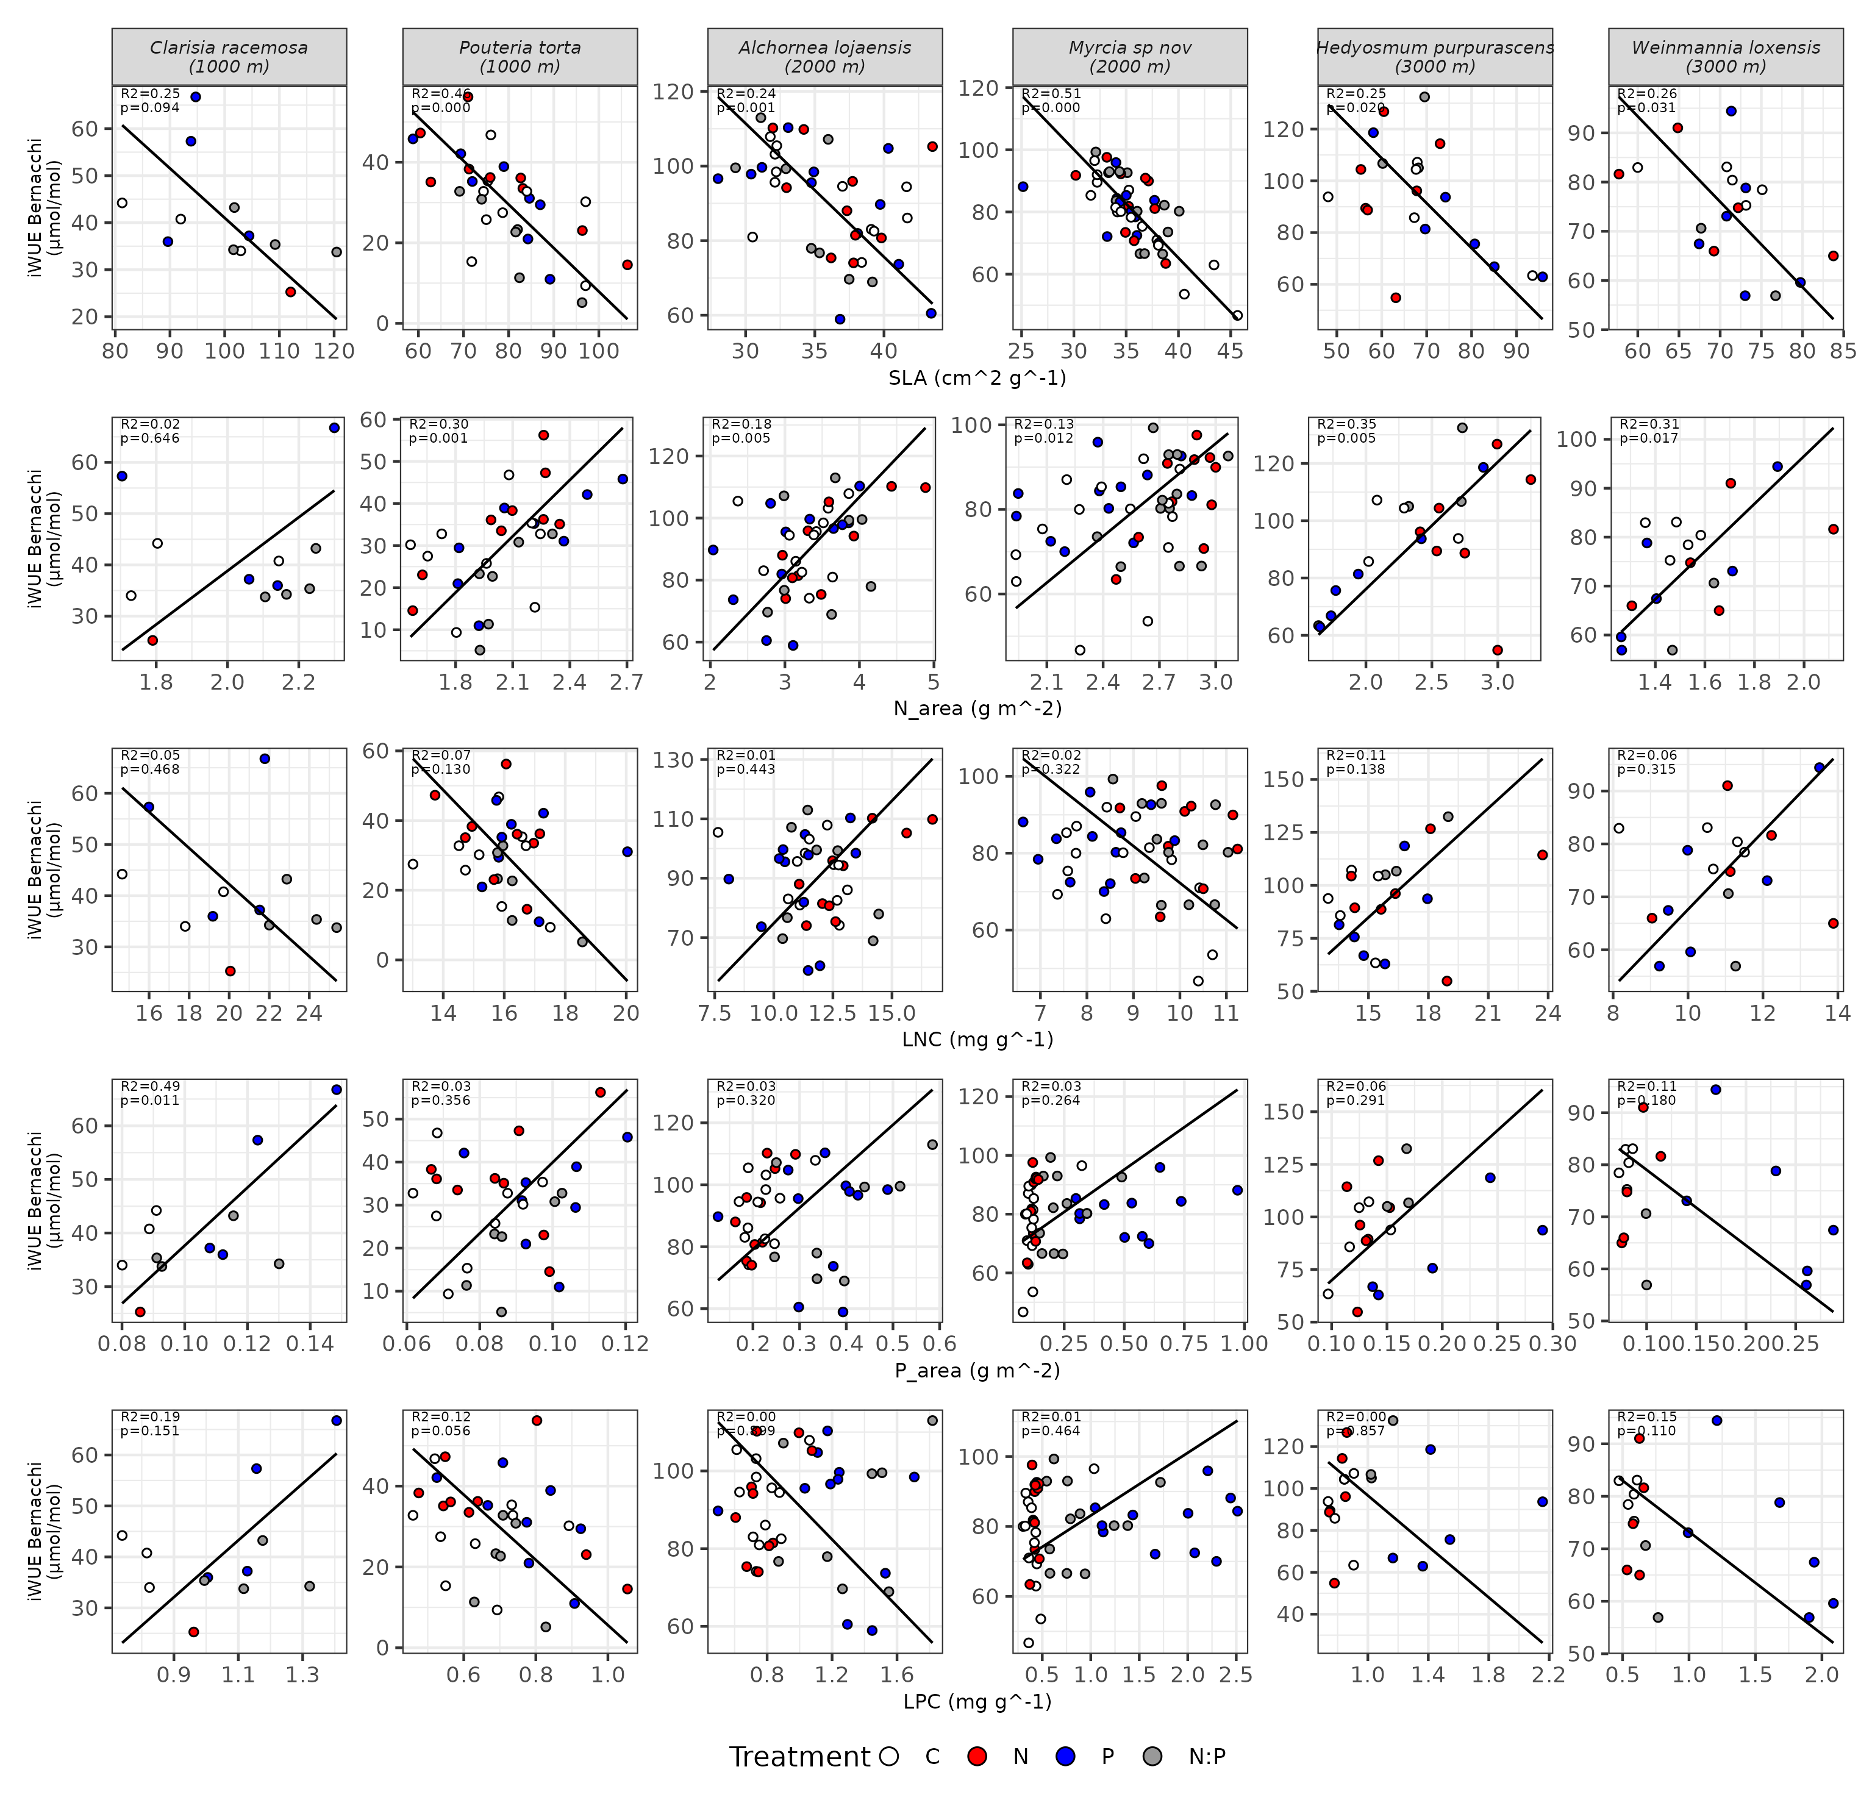
Figure S_. Relationship between iWUE (Bernacchi) and five leaf traits —SLA, N_area, LNC, P_area, LPC—, by species (column headers also show the elevation of that species' site, since species and elevation coincide 1:1 in this design). Black line = SMA regression; circles coloured by treatment (C = control, N, P, N:P). Axes were left free per panel because each trait has different units and ranges. R² and p for each panel shown in the top-left corner.

Table S_ — full SMA results (5 traits × 6 species)
Trait (x) | Species | n | SMA slope (95% CI) | Intercept | R² | p
SLA (cm² g⁻¹) | Clarisia racemosa | 12 | -1.05 (-1.87 to -0.59) | 146.31 | 0.25 | 0.094 †
SLA (cm² g⁻¹) | Pouteria torta | 32 | -1.08 (-1.42 to -0.82) | 116.03 | 0.46 | <0.001 ***
SLA (cm² g⁻¹) | Alchornea lojaensis | 42 | -3.58 (-4.71 to -2.72) | 218.78 | 0.24 | 0.001 **
SLA (cm² g⁻¹) | Myrcia sp nov | 49 | -3.49 (-4.27 to -2.84) | 204.63 | 0.51 | <0.001 ***
SLA (cm² g⁻¹) | Hedyosmum purpurascens | 21 | -1.74 (-2.60 to -1.16) | 212.95 | 0.25 | 0.020 *
SLA (cm² g⁻¹) | Weinmannia loxensis | 18 | -1.74 (-2.70 to -1.12) | 197.44 | 0.26 | 0.031 *
N_area (g m⁻²) | Clarisia racemosa | 12 | 52.29 (27.30 to 100.17) | -65.74 | 0.02 | 0.646
N_area (g m⁻²) | Pouteria torta | 32 | 44.54 (32.77 to 60.53) | -61.32 | 0.30 | 0.001 **
N_area (g m⁻²) | Alchornea lojaensis | 42 | 25.16 (18.91 to 33.48) | 6.13 | 0.18 | 0.005 **
N_area (g m⁻²) | Myrcia sp nov | 48 | 36.56 (27.81 to 48.06) | -14.10 | 0.13 | 0.012 *
N_area (g m⁻²) | Hedyosmum purpurascens | 21 | 44.38 (30.39 to 64.80) | -12.63 | 0.35 | 0.005 **
N_area (g m⁻²) | Weinmannia loxensis | 18 | 48.73 (31.75 to 74.79) | -0.90 | 0.31 | 0.017 *
P_area (g m⁻²) | Clarisia racemosa | 12 | 541.18 (333.90 to 877.14) | -16.46 | 0.49 | 0.011 *
P_area (g m⁻²) | Pouteria torta | 32 | 824.31 (575.27 to 1181.17) | -42.50 | 0.03 | 0.356
P_area (g m⁻²) | Alchornea lojaensis | 41 | 133.97 (97.81 to 183.49) | 52.38 | 0.03 | 0.320
P_area (g m⁻²) | Myrcia sp nov | 49 | 57.68 (43.35 to 76.75) | 66.33 | 0.03 | 0.264
P_area (g m⁻²) | Hedyosmum purpurascens | 20 | 475.36 (299.20 to 755.23) | 22.32 | 0.06 | 0.291
P_area (g m⁻²) | Weinmannia loxensis | 18 | -145.20 (-234.95 to -89.73) | 93.54 | 0.11 | 0.180
LNC, mass (mg g⁻¹) | Clarisia racemosa | 12 | -3.53 (-6.69 to -1.86) | 112.74 | 0.05 | 0.468
LNC, mass (mg g⁻¹) | Pouteria torta | 32 | -9.08 (-12.90 to -6.39) | 175.80 | 0.07 | 0.130
LNC, mass (mg g⁻¹) | Alchornea lojaensis | 42 | 8.25 (6.04 to 11.28) | -7.70 | 0.01 | 0.443
LNC, mass (mg g⁻¹) | Myrcia sp nov | 48 | -9.58 (-12.80 to -7.17) | 168.10 | 0.02 | 0.322
LNC, mass (mg g⁻¹) | Hedyosmum purpurascens | 21 | 8.59 (5.54 to 13.32) | -44.04 | 0.11 | 0.138
LNC, mass (mg g⁻¹) | Weinmannia loxensis | 18 | 7.34 (4.48 to 12.01) | -5.77 | 0.06 | 0.315
LPC, mass (mg g⁻¹) | Clarisia racemosa | 12 | 55.77 (30.72 to 101.25) | -18.10 | 0.19 | 0.151
LPC, mass (mg g⁻¹) | Pouteria torta | 32 | -80.69 (-113.78 to -57.22) | 86.28 | 0.12 | 0.056 †
LPC, mass (mg g⁻¹) | Alchornea lojaensis | 41 | -43.02 (-59.14 to -31.28) | 133.98 | 0.00 | 0.899
LPC, mass (mg g⁻¹) | Myrcia sp nov | 49 | 17.94 (13.45 to 23.92) | 65.19 | 0.01 | 0.464
LPC, mass (mg g⁻¹) | Hedyosmum purpurascens | 20 | -60.83 (-97.97 to -37.77) | 157.50 | 0.00 | 0.857
LPC, mass (mg g⁻¹) | Weinmannia loxensis | 18 | -19.48 (-31.19 to -12.17) | 92.73 | 0.15 | 0.110
Table S_. SMA slope (with 95% confidence interval), intercept, R² and p-value for the test of slope = 0, for iWUE (Bernacchi) vs. each leaf trait, species by species. *** p<0.001, ** p<0.01, * p<0.05, † p<0.10. n varies among species (range 12-49) because sample size per species differs.

Table S_ — control-plot means by species/site (elevation pattern)
Species | Site | Elevation (m) | N_area (g m⁻²) | SLA (cm² g⁻¹) | iWUE Bernacchi (µmol/mol)
Clarisia racemosa | BoN | 1000 | 1.89 | 92.1 | 39.7
Pouteria torta | BoN | 1000 | 1.94 | 81.1 | 28.4
Alchornea lojaensis | SFNu | 2000 | 3.27 | 35.7 | 92.2
Myrcia sp nov | SFNu | 2000 | 2.43 | 36.2 | 76.6
Hedyosmum purpurascens | CaNu | 3000 | 2.15 | 68.9 | 90.9
Weinmannia loxensis | CaNu | 3000 | 1.48 | 70.1 | 80.0
Table S_. Mean N_area, SLA and iWUE (Bernacchi) in control trees, by species. Bombuscaro/1000 m: n=3 (C. racemosa) and n=9 (P. torta). San Francisco/2000 m: n=12 (A. lojaensis) and n=15 (Myrcia). Cajanuma/3000 m: n=5 and n=5 (H. purpurascens, W. loxensis).

Methodological note — how these numbers were computed
Values in this table and figure were computed by running smatr::sma() directly on data_for_R_Bernacchi.xlsx, species by species, for the five traits (SLA, N_area, P_area, LNC, LPC) against iWUE_Bernacchi (µmol/mol). Control-plot means in the elevation table use only control trees (Treatment = C). The R code that reproduces this table and figure is the same sma.Rmd already shared with Andrea in this conversation.

